Ideation Phase
Empathize & Discover

Date | 17-12-2025
Team ID
Project Name | Video Conferencing App
Maximum Marks | 4 Marks

Empathy Map Canvas:
Understand the needs, frustrations, and behaviours of users participating in or hosting online meetings through a platform like Video Conferencing App.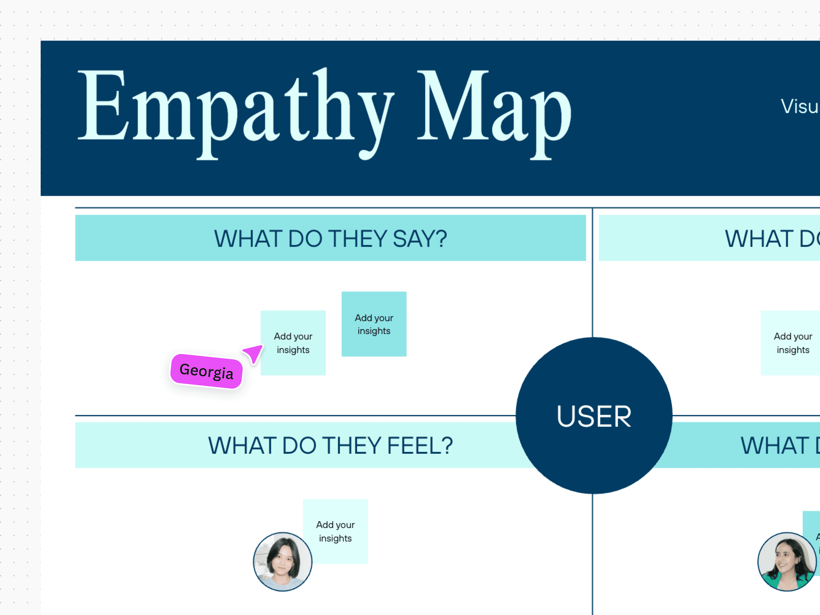

Reference: https://www.mural.co/templates/empathy-map-canvas

